Significance 301

Significance 301

“Everybody needs meaning because the alternative, meaninglessness, is unlivable.”
– Os Guinness

Imago Dei – Created in God’s Image

The two most important days of your life are: The day you were born, and the day you found out why.

Knowing the reason for your existence is vital to you living a meaningful life, full of purpose, fulfillment, and significance. Discovering what you were created to do always begins with discovering who you were created to be. The first question to ask yourself then, is, “Who am I?”

The Bible, in Genesis chapter 1, gives us the answer!

Then God said, “Let us make human beings in our image, to be like us. They will reign over the fish in the sea, the birds in the sky, the livestock, all the wild animals on the earth, and the small animals that scurry along the ground.” So God created human beings in his own image. In the image of God he created them; male and female he created them. Then God blessed them and said, “Be fruitful and multiply. Fill the earth and govern it. Reign over the fish in the sea, the birds in the sky, and all the animals that scurry along the ground.” Genesis 1:26-27 (NLT - Emphasis added)

You are created in the image of God.

Of all of God’s creations, human beings are the only ones that were created in God’s image. God called all that he created good, but when he finished forming humans, He chose to call us very good. We were created with this unique distinction because we are significant!

“And He has made from one blood every nation of men to dwell on all the face of the earth, and has determined their preappointed times and the boundaries of their dwellings.” Acts 17:26 (NKJV)

Imago Dei is Latin for the “image of God.” Since every human being is created in God’s image, then every human being has been given inherent dignity, value, and worth. We are made of One Blood. We are One Human race created in the image of God.

Your life matters to God. Your life is important because you were made by Him and for Him. Take a moment to think about the great detail and artistry that went into creating you.

You formed my innermost being, shaping my delicate inside and my intricate outside, and wove them all together in my mother’s womb. Psalm 139:13 (TPT)

Your DNA is the material that carries instructions for how your body is meant to look and work. Every human’s DNA contains unique sequences – there are no repeats. According to an article published in the 2014 Journal of Pharmaceutical and Biomedical Sciences, there are 70,368,744,177,664 possible combinations for human DNA. There are more combinations of human DNA than stars in the Milky Way Galaxy.

For we are God’s masterpiece. He has created us anew in Christ Jesus, so we can do the good things he planned for us long ago. Ephesians 2:10 (NLT)

You were created intentionally and with a great purpose! Your meaning (the reason for your existence) was communicated by God from the beginning of time because He chose you to be in relationship with Him before the foundation of the world was set in place! Before you ever had a chance to know who you are and what you were created to do, God, your heavenly Father, already knew you and planned the good things you would do.

This truth is wonderful and powerful because it shows us that our identity (who we are) can be found when we look to God, our Creator. He is the one who made us and He is the one who gives our lives meaning.

Responsibility – Created for God’s Purpose

But why were you created? And why were you created in the image of God?

The creator has the responsibility to define the purpose of his creation. This is true of every created thing. Consider an automobile. The creator of the vehicle defines its purpose. Is it an off-road truck? Is it a fuel-efficient commuter? Is it a large capacity family transporter? The creator defines the purpose, and the creator’s definition of purpose is objective truth.

Anyone else, besides the creator, can only share their subjective opinion on the purpose of the creation – but it can never be objective truth. Just as it does not make sense to take the fuel-efficient commuter up a mountain trail, we cannot define our own purpose because we did not create ourselves. Our purpose comes from God, who created us and knows everything about us.

“He is the God who made the world and everything in it. Since he is Lord of heaven and earth, he doesn’t live in man-made temples, and human hands can’t serve his needs—for he has no needs. He himself gives life and breath to everything, and he satisfies every need. From one man he created all the nations throughout the whole earth. He decided beforehand when they should rise and fall, and he determined their boundaries. His purpose was for the nations to seek after God and perhaps feel their way toward him and find him—though he is not far from any one of us. ²⁸ For in him we live and move and exist” Acts 17:24-28 (NLT)

You were created to carry responsibility.

…neither wild plants nor grains were growing on the earth. For the Lord God had not yet sent rain to water the earth, and there were no people to cultivate the soil. Genesis 2:5 (NLT -Emphasis added.)

The Lord God placed the man in the Garden of Eden to tend and watch over it.
Genesis 2:15 (NLT-Emphasis added)

The word here for “tend” and “cultivate” is the same, and it means to work and serve. The word here for “watch” means to preserve.

Putting it Together.

You and I were created to work, serve, and preserve God’s creation! This is the purpose of our creation and how we find our individual purpose. This responsibility brings dignity to our lives!

We do this when we choose to exercise the influence God has given us in various areas of creation. The areas of his creation that we are created to care for are Family, Church, Business, Arts & Entertainment, Science & Medicine, Media, Government and Education.

Knowing our identity and taking responsibility unlocks the elevated, abundant life and allows us to live in the purpose God has given us – to reign and rule! (Genesis 1:27) Walking in this responsibility is a choice. And it is our choices that determine how effective we are in all those spheres of influence. As image bearers of God, we rule and reign as he does – with Love and Truth.

Finding our significance begins with learning how to love – first God then others.
And He said to him, “ ‘You shall love the Lord your God with all your heart, and with all your soul, and with all your mind.’ This is the great and foremost commandment. The second is like it, ‘You shall love your neighbor as yourself.’ Upon these two commandments hang the whole Law and the Prophets.” Matthew 22:37-40 (NASB 2020)

As we are learning how to love God and others we can study the life of Jesus because he was the visible image of the invisible God.

“Christ is the visible image of the invisible God. He existed before anything was created and is supreme over all creation, for through him God created everything in the heavenly realms and on earth. He made the things we can see and the things we can’t see— such as thrones, kingdoms, rulers, and authorities in the unseen world. Everything was created through him and for him.” Colossians 1:15-16 (NLT)

“And we know that the Son of God has come, and he has given us understanding so that we can know the true God. And now we live in fellowship with the true God because we live in fellowship with his Son, Jesus Christ. He is the only true God, and he is eternal life.” 1 John 5:20 (NLT)

Transformation

Only God’s truth brings transformation. His truth is expressed through his written Word and his personal presence.

We can all draw close to him with the veil removed from our faces. And with no veil we all become like mirrors who brightly reflect the glory of the Lord Jesus. We are being transfigured into his very image as we move from one brighter level of glory to another. And this glorious transfiguration comes from the Lord, who is the Spirit. 2 Corinthians‬ 3:18‬ (TPT)‬‬ ‬‬‬‬‬‬‬‬‬‬‬‬‬‬‬‬‬‬‬‬

The more time we spend in the Presence of God, the more we are transformed into the image of God. And not just any image but the specific aspect of himself that he created us to share with the world.

“God’s grace turns out men and women with a strong family likeness to Jesus Christ – not milksops.” Oswald Chambers, author of My Utmost for His Highest

Your word is a lamp to guide my feet and a light for my path.
Psalm 119:105 (NLT)

“Don’t copy the behavior and customs of this world, but let God transform you into a new person by changing the way you think. Then you will learn to know God’s will for you, which is good and pleasing and perfect.” Romans‬ (12:2‬ NLT‬‬‬‬‬‬‬‬‬‬‬‬‬‬‬‬)‬‬‬‬‬‬‬‬‬‬

It is important to remember we are created in the image of God, and He is not created in the image of man. When we try to remake God into our image, we are fashioning an idol that will lead us away from our purpose and significance.

Jesus said to the people who believed in him, “You are truly my disciples if you remain faithful to my teachings. And you will know the truth, and the truth will set you free.” John 8:31-32 (NLT)

You don’t get free by focusing on the thing you’re trying to get free from. You get free by focusing on the truth that sets you free - His name is Jesus!! To know the truth is to love and spend time with him.

Spending time in the Bible.

One of the best ways to spend time in God’s Presence is to engage with him as you read through the Bible. Scripture opens us up to God’s direction and correction – plus it has HUGE benefits on our life! The Center of Bible Engagement compiled extensive research findings by Arnold Cole, Ed.D. & Pamela Caudill Ovwigho, Ph.D. into a document titled “Understanding the Bible Engagement Challenge: Scientific Evidence for the Power of 4.”

The study polled 40,000 people ages 8 to 80 seeking to see how people were engaging in Scripture. People who engaged with their Bibles one time per week – including at weekend church services – had minimal impact on their lives. People who engaged two or three times had minor improvements. The real revelation was how significantly the data shifted on the fourth day! People who engaged at least four days per week found:
- Feeling lonely drops 30%
- Anger issues drop 32%
- Bitterness in relationships drops 40%
- Alcoholism drops 57%
- Sex outside of marriage drops 68%
- Feeling spiritually stagnant drops 60%
- Viewing pornography drops 61%
- Sharing your faith jumps 200%
- Discipling others jumps 230%

Finding your significance.

You were created on purpose for a purpose. The search for significance and purpose is found as you (1) love God, others, and yourself, (2) spend time in God’s Presence allowing him to transform you, and (3) begin to exert your influence in the areas he has called you to. True significance is found as you embrace who God created us to be and allow that expression of himself to touch the world around us.

Practical Steps to Transformation

- Read the Bible! We offer “The Biblecast” every Monday-Thursday at 7:00am on Facebook live, YouTube, and as a podcast. You can begin your day by reading the Bible with Pastor Jimmy Witcher. He will guide you through a short ten-minute section of scripture! If you miss the live broadcast at 7:00am, you can catch up later in the day on YouTube or wherever you stream podcasts.
- Read, declare, and memorize the attached “I am” statements.
- Listen to the “Father’s Love Letter” recording. (https://www.fathersloveletter.com/)

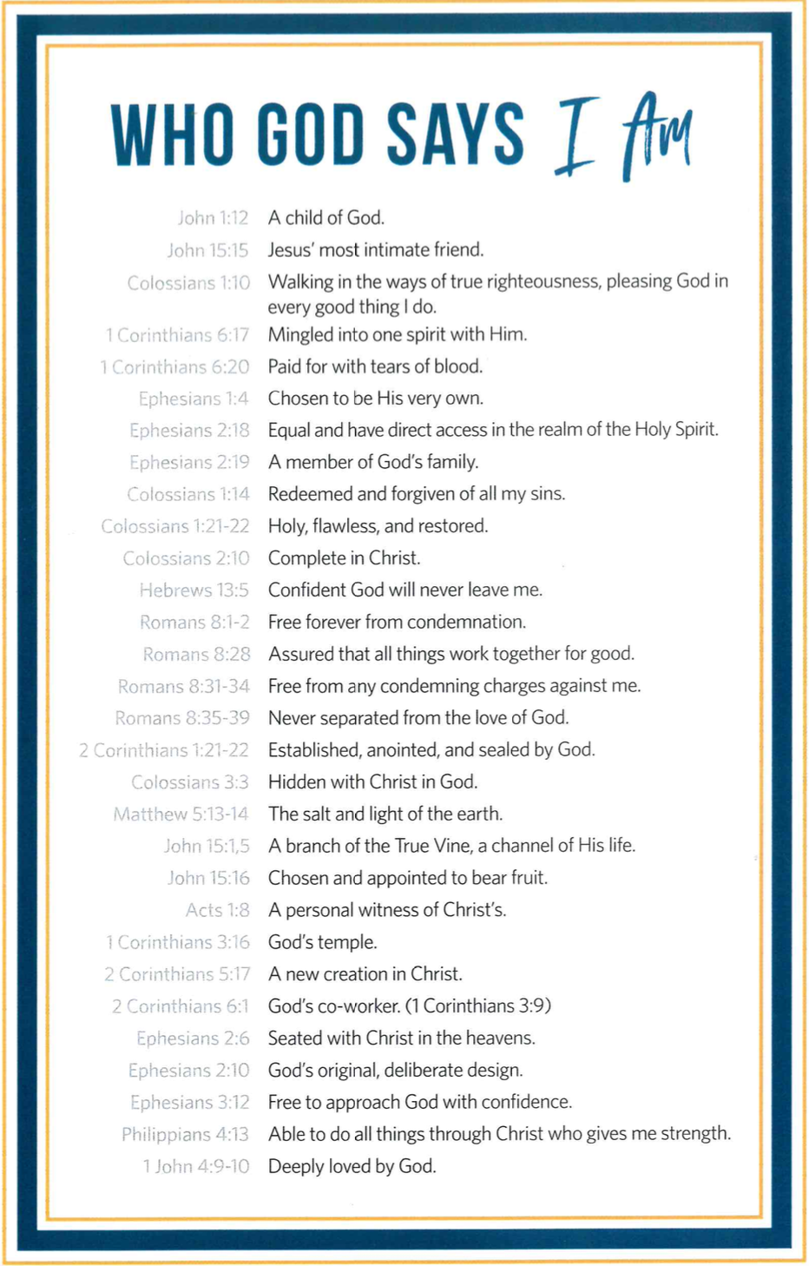

James Strong, A Concise Dictionary of the Words in the Greek Testament and The Hebrew Bible (Bellingham, WA: Logos Bible Software, 2009), 84.

